Circuit Analysis (Lab # 2)
Experiment 2: Measurements of Waveforms and Fundamental Quantities, Basic resistive circuits.

Name: Waqas Ali Registration No: 2025-CE-99.

Date: 16th March, 2026. Grade and Signature: ………………………

CLO3 | Make measurements in their own constructed electric circuits.
Psychomotor/Affective | Level1  (1) | Level2 (2-3) | Level3 (4-5) | Level4 (6-7)
Report Marks (3) |  |  | Total marks  (10)
_______________________________________________________________________________
_
Objectives: This experiment will provide exposure to measurements of waveforms and Fundamental Quantities, Basic resistive circuits. A primary purpose of this lab course is for you to master the use of electronic test equipment and measurement of fundamental quantities.
Equipment required:
Power Supply, Breadboard, Oscilloscope, Signal Generator Connecting wires, Resistances, Multimeter. Procedure

Experiment # 1
SIGNAL GENERATOR AND OSCILLOSCOPE
- Use the signal generator and the oscilloscope to perform the following tasks.
- Build circuit ‘A’ shown below in Figure 1.
- Set the signal generator to generate a sinusoidal signal with a frequency of 100 Hz and peak-to peak voltage of 5V.
- Set up one probe across input signal, and another across R1 and R2 alternatively.
- Measure and draw all the voltages and time related parameters on the graphs below.

Experiment # 01
Solution and simulation on Proteus:

Given circuit:
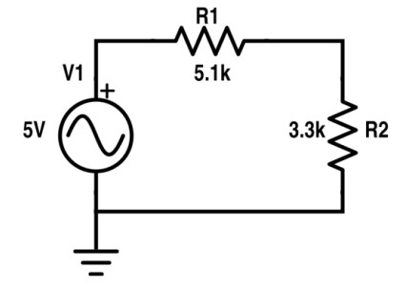
Figure 1 Circuit ‘A

Resistor | Input voltage | RMS Voltage | P-P Voltage
R1 | 5V (P-P) | 1.07V | 3.04V
R2 | 5V (P-P) | 0.69V | 1.96V

Explanation:
The given circuit has two resistances in series with an A.C source. Following steps are performed to solve the circuit and, it’s simulation on Proteus.
- Components & Parameters:
- AC Source (Alternator): 5V Peak-to-Peak Sine wave.
- Resistors: R1 = 5.1kΩ and R2 = 3.3kΩ in series.
- Total Resistance Calculation:
- R_{t}= R1 + R2 = 8.4 kΩ
- Time Period:
- T=1/f
- T=1/100=10ms.
- P-P Voltage Calculation:
- Used the Voltage Divider Rule:
  - V_{x}=V_{source} x (R_{x} / R_{t})
  - V_{R1}=5V x (5.1kΩ / 8.4kΩ) = 3.04V.
  - V_{R2}=5V x (3.3kΩ / 8.4kΩ) = 1.96V.
- RMS Voltage Calculation:
- Formula: V_{rms} = (V_{p-p}/ 2) x 0.707.
- V_{rms1} = (3.04V / 2) x 0.707=1.07V
- V_{rms2} = (1.96V / 2) x 0.707=0.69V
- Converted each calculated P-P value to find the effective voltage.
- Oscilloscope Measurement:
- Channel A: Measured total input voltage.
- Channel B: Measured voltage across R2 (relative to ground).
- Subtraction: Calculated R1 voltage by finding the difference between Channel A and B.

Graphs in DSO (Proteus):

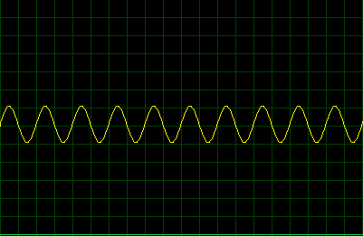
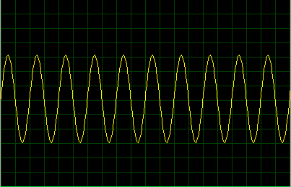

Horizontal: 5ms/division Vertical: 2.5V/division  One complete wave in 2 horizontal and, 2 vertical boxes | Horizontal: 5ms/division Vertical: 0.5V/division  One complete wave in 2 horizontal and, 6 vertical boxes.
Figure 2 Input Voltage Signal | Figure 3 Voltage across R1
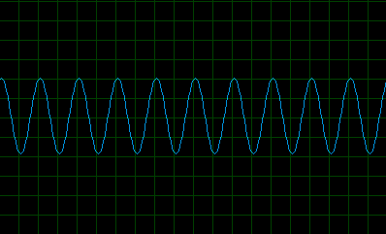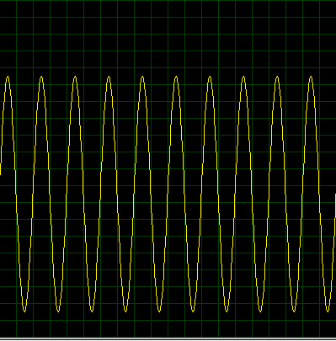
Horizontal: 5ms/div Vertical: 0.5V/div  One complete wave in 2 horizontal and, 4 vertical boxes. | Horizontal: 5ms/div Vertical: 0.5V/div  One complete wave in 2 horizontal and, 14 vertical boxes.
Figure 5 Voltage Signal across R2 | Figure 6 Draw 7V Sinusoidal

Experiment # 2
SIGNAL GENERATOR AND OSCILLOSCOPE
- Use the signal generator and the oscilloscope to perform the following tasks.
- Build circuit ‘B’ shown below in Figure 7.
- Set the signal generator to generate a sinusoidal signal with a frequency of 200 Hz and peak-to peak voltage of 7V.
- Set up one probe across input signal, and another across R1, R2 and R3 alternatively.
- Measure and draw all the voltages and time related parameters on the graphs below.

Experiment # 02
Solution and simulation on Proteus:

Given circuit:

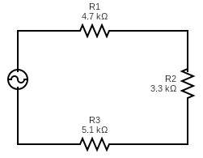

 |  | Figure 7 Circuit ‘B’
Resistor | Input voltage |  | RMS Voltage |  | P-P Voltage
R1 | 7V (P-P) |  | 0.89V |  | 2.51V
R2 | 7V (P-P) |  | 0.62V |  | 1.76V
R3 | 7V (P-P) |  | 0.97V |  | 2.73V
R1 and R2 | 7V (P-P) |  | 1.51V |  | 4.27V
R2 and R3 | 7V (P-P) |  | 1.59V |  | 4.49V

Explanation:
The given circuit has three resistances in series with an A.C source. Following steps are performed to solve the circuit and, it’s simulation on Proteus.
- Components & Parameters:
- AC Source (Alternator): 7V Peak-to-Peak Sine wave.
- Resistors: R1 = 4.7kΩ, R2 = 3.3kΩ and R3 = 5.1kΩ in series.
- Total Resistance Calculation:
- R_{t}= R1 + R2 + R3 = 13.1kΩ
- Time Period:
- T=1/f
- T=1/200=5ms.
- P-P Voltage Calculation:
- Used the Voltage Divider Rule:
  - V_{x}=V_{source} x (R_{x} / R_{t})
  - V_{R1}=5V x (4.7kΩ / 13.1kΩ) = 3.04V.
  - V_{R2}=5V x (3.3kΩ / 13.1kΩ) = 1.76V.
  - V_{R3}=5V x (5.1kΩ / 13.1kΩ) = 2.73V.
  - V_{R1-R2}=5V x (5.1kΩ / 13.1kΩ) = 4.27V.
  - V_{R3-R4}=5V x (5.1kΩ / 13.1kΩ) = 4.49V.
- RMS Voltage Calculation:
- Formula: V_{rms} = (V_{p-p}/ 2) x 0.707.
- V_{rms1} = (3.04V / 2) x 0.707=0.89V
- V_{rms2} = (1.76V / 2) x 0.707=0.62V
- V_{rms2} = (2.73V / 2) x 0.707=0.97V
- V_{rms1-2} = (4.27V / 2) x 0.707=1.51V
- V_{rms2-3} = (4.49V / 2) x 0.707=1.59V
- Converted each calculated P-P value to find the effective voltage.
- Oscilloscope Measurement:
- Channel A: Measured total input voltage.
- Channel B: Measured voltage across R2 (relative to ground).
- Subtraction: Calculated R1 voltage by finding the difference between Channel A and B, R2 by difference between channel B and C. Similarly for R1-R2 and, R2-R3.

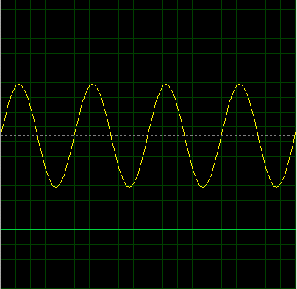
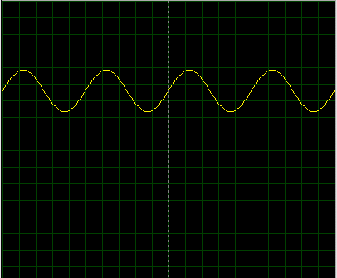
Graphs in DSO (Proteus):
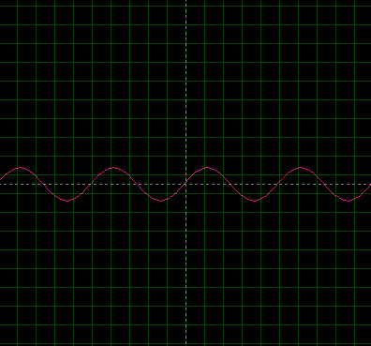
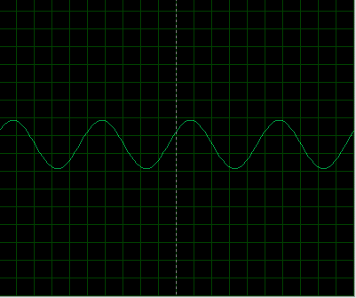
Horizontal: 1ms/div Vertical: 0.5V/div  One complete wave in 5 horizontal and, 4 vertical boxes. | Horizontal: 1ms/div Vertical: 0.8V/div  One complete wave in 5 horizontal and, 3 vertical boxes.
Figure 8 Input Voltage Signal | Figure 9 Voltage Signal across R1

Horizontal: 1ms/div Vertical: 0.9V/div  One complete wave in 5 horizontal and, 2 vertical boxes. | Horizontal: 1ms/div Vertical: 1.5V/div  One complete wave in 5 horizontal and, 3 vertical boxes.
Figure 10 Voltage Signal across R2 | Figure 11 Voltage Signal across R3

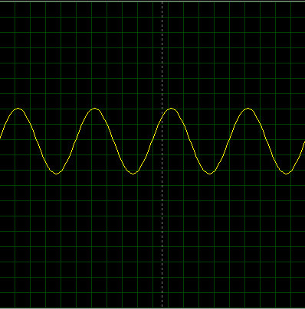
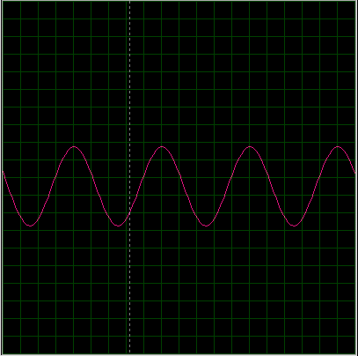
Horizontal: 1ms/div Vertical: 1.06V/div  One complete wave in 5 horizontal and, 4 vertical boxes. | Horizontal: 1ms/div Vertical: 1V/div  One complete wave in 5 horizontal and, 3 vertical boxes.
Figure 12 Voltage Signal across R1 and R2 | Figure 13 Voltage Signal across R2 and R3

Post Lab Questions
- Define Ohm’s law.
Ohm’s Law states that the current flowing through a conductor is directly proportional to the voltage across the two points, provided the temperature remains constant. It is expressed by the formula:
V= I x R
- What is resistor?
A resistor is a passive two-terminal electrical component that implements electrical resistance as a circuit element. Its primary function is to reduce current flow and lower voltage levels within a circuit.
- How resistor works?
A resistor works by converting electrical energy into heat energy. As electrons flow through the resistive material, they collide with the ions in the material, creating "friction" that slows them down. This restricts the flow of charge (current) according to its ohmic value.

- What is your inference from the input and output waveforms on oscilloscope?
Amplitude: The output waveform across an individual resistor has a smaller amplitude than the input waveform because the total voltage is shared (dropped) across all resistors in series.
Phase & Frequency: The frequency and phase of the output waveforms remain identical to the input waveform, resistors change the magnitude of the voltage but do not alter the timing or shape of the signal.
- Show calculations of 7V input signal (Figure 10) from signal generator.
  - Voltage calculations (Following volt/dev and number of boxes of oscilloscope)
If the oscilloscope is set to 1V/div and the input is 7V p-p, the wave will span 7 vertical boxes. For R1 (2.51V p-p), the wave will span approx. 2.5 boxes at the same 1V/div setting.
  - Frequency/Period calculations (Following Steps in frequency measurements section)
T=1/f
T=1/200=5ms.
If time period is set to 1ms, it’ll take 5 horizontal boxes to complete one cycle
  - Current calculation (Ohm Law)
Calculating the peak-to-peak current I_{p-p}:
R_{t}= R1 + R2 + R3 = 13.1kΩ
I_{p-p} = V_{p-p}/ R_{t} = 7V/13.1kΩ = 0.534mA

